**Business model-**

**Business-to-Consumer (B2C)-**

Business-to-consumer or B2C startup business model refers to those businesses that sell their services or products directly to the consumers or people who are the end-users of their product or service. While there are many examples of B2C companies in India, the best one to look at would be e-commerce portals but their are also companies like Dell that sell their manufactured products directly to the customer.

**Advantages of B2C business model-**

**a) Lower Cost-** As compared to any other startup business model, B2C has the lowest cost as you communicate and deal directly with the end consumer and thus eliminate the cost that many lose to brokers in between.

**b) 24/7 shop and searchability-** With the arrival of the digital age and e-commerce sites, the B2C startup business model now has the added advantage of having a “shop” open 24/7 in the form of the online site which also easy to search on the net and app platforms.

**c) Sharing information directly with consumers-** As compared to other business models, B2C has the added advantage of having direct contact with their end consumers. This enables them to share any information with them easily. In fact, you can also pitch your products directly to them via emails, apps stores etc.

**In online business-to-consumer sales, the business model effective for our product is -**

**Direct Sellers(Direct to Consumer)-**

This is the type most people are familiar with – they are the online retail sites where consumers buy products. They can be manufacturers such as Gap or Dell or small businesses that create and sell products, but they can also be online versions of department stores selling products from a wide range of brands and manufacturers. Examples include Flipkart etc.

A huge benefit of having a D2C(Direct to Consumer) e-commerce strategy in our business model is that manufacturers gets full control of all their activities, from packaging to marketing. In out start-up it is highly important as our product is not of general use but is acquired by people who are keenly interested in gardening or farming. So, marketing techniques has to be more product centric. Its packaging and delievery is also more sensitive then other general products as it includes various sensors which are quite delicate.

In a traditional retailer business model, a manufacturer has little control when their products are being sold by retailers. A D2C e-commerce strategy gives a manufacturer back the control over its marketing efforts and sales strategies, and it puts the company directly in contact with the end-consumer. D2C gives a manufacturer total control of its customers’ experience from the research phase to purchase. In our product this direct control and interaction with consumers is highly important as it will improve after validation learning or taking feedback from customers. They can give direct inputs or suggestion which is highly beneficial.

**Why and How D2C for our product-**

**Strong Customer Relationships-** Direct sales gives a small business like ours the ability to build and manage our own personal relationships with our customers. These relationships can help our business better understand and adapt to the needs of our customers as our product will be improved drastically according to the feedback of customers.

**Coordination with Other Business Strategies-** Using this model we controls our sales force, so we gain the ability to coordinate our sales interactions with our production and marketing strategies. We can also use feedback from our direct sales interactions to evaluate the effectiveness of our marketing campaigns, and to tailor our development of products or services to consumer interests.

**Cost and Price Control-** This model provides us significant degree of control over our pricing and distribution. As a result, our business has greater capability to verify that our products are competitively priced.

**Access to More Consumers-** A direct selling campaign allows access to consumers which otherwise may not reach. Not all customers receive or respond to media advertising campaigns. Similarly, some customers may not shop at the retail stores that stock a business's products. The direct sales model gives us a way to get to these customers directly and initiate a sale.

**Our business model-**

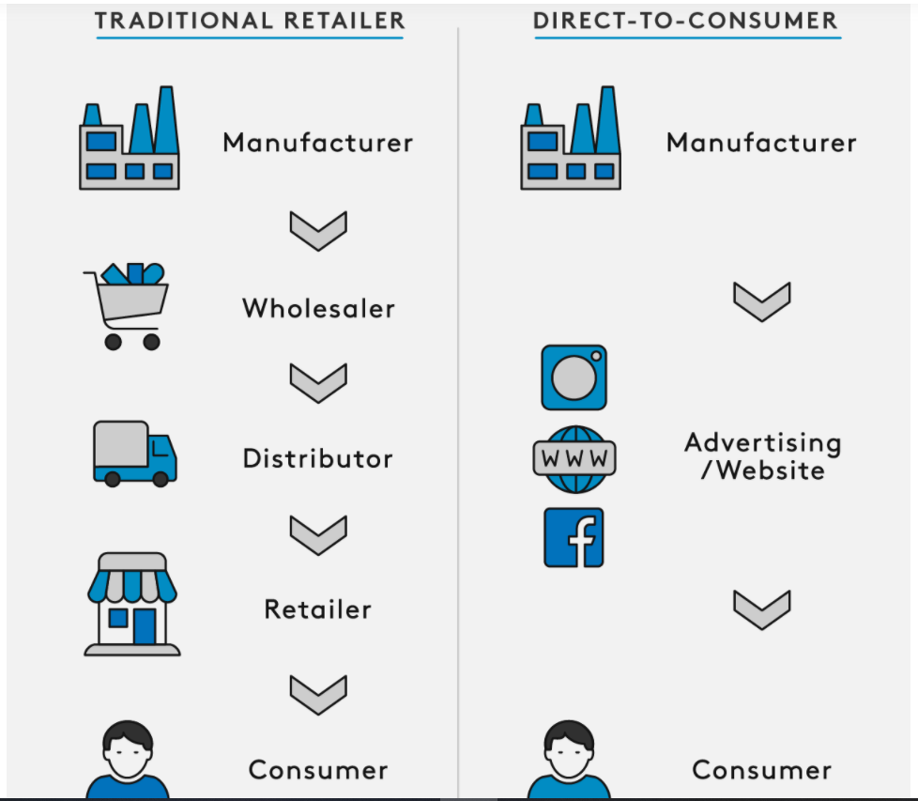

Some research related to our product-

**Our Target Market-**

1. **Primary Target Market-** Individual persons whose profession is not farming who want to pursue it as a hobby and nutritients conscious people who would like to use organic vegetables and fruits.

**Our Competition-**

1- Current start-ups based on our concept :

1: Letcetra Agritech

2: Acqua Farms

3:GP Solutions

2- All devices and products used for growing at homes.

1: **Agro2o® Smart Garden:**

**Potential Customers-**

1- Urban people: Since urban who would like to grow the vegetables and would like to take gardening as the hobby. Most of the urban people do not have big land for growing the garden and grow vegetables our product is a perfect fit for these people. Which can fit inside a room, balcony or even an unused corner at their homes. This pod can be used for growing the vegetables organically which is a big demand nowadays due to preservation technique. Fertilisers and pesticides are also one of the other harms these days in the vegetables which has to survive longer duration of the logistics from where they are grown to where they are consumed. So the pod serves as the most promising place for growing the organic vegetables.

2- Farmers for teaching: This is one of the potential customers, we will not directly sell them but our pod will be used to teach them about hydroponics and further if they found out right for their place, they can be provided all the other necessary materials for growing the vegetables and fruits with the help of hydroponics at their farms.

3- Farming colleges and institutes: This pod can be used at the colleges and research institutes forteaching the students about the latest trends in hydroponics and similar field of study.

4: Restaurants and hotels: This pod can be used by the restaurants and hotels for growing their own vegetables and fruits such as lettuce, spinach, tomatoes and strawberries for their dishes. It will make them self-sustainable and reduce their dependence on the outer market without compromising with the quality of the vegetables and fruits.

**Revenue Streams-**

1. Selling the pod-
   1. Selling the pod at cost decided.
   2. Selling the pod at less cost but with some limited features, remaining money will be generated when user will buy premium membership having all features.

2- Rent our product to colleges or schools for studies and awareness- Our product can be rent at some fix price(what will be price) to universities teaching farming as main subject. (have to talked to any such college) This method is highly equipped with technology whose demand is growing day by day. Students will be able to get hands on and practical experience with hydroponic farming. It will enhance practical learning and hence will be promoted by colleges and schools.

<https://luxe.digital/business/digital-luxury-reports/direct-to-consumer-business-strategy/>

<https://www.shopify.com/blog/business-plan-template?ref=moonshot-digital>

<https://docs.google.com/document/d/1oUfW6n7w-7kVp6nWtAWMyabfppcN5p0XSOZ3EP3V52E/edit>

<https://www.slideshare.net/dulanmahendra/dell-direct-business-model>

<https://www.marketing91.com/business-model-of-dell/>

**Conclusion-**

It’s a significant shift in strategy for any business, one that entails a different set of skills that will necessitate input from tech, sales and marketing, data, and operations.

That said, the majority of our economy is now internet-based, and the lifeblood of that economic engine is data. According to a recent IAB study, over two-thirds of consumers have come to expect direct access to a brand, and about 67% of customers have used a company’s social media for customer support.

So if you want to keep up and reach more customers in more parts of the world in a more relevant way, you’re going to have to make the change.

Case analysis of